(Approx. 1360 words)

So You Want to Write a Book
By Dick Maybach, Member, Brookdale Computer Users’ Group, NJ
April 2015 issue, BUG Bytes
www.bcug.com
n2nd (at) att.net

Perhaps you want to document your family's history or preserve a collection of recipes, or you may have idea you think you could sell to others. Not long ago, you would have few choices between a loose-leaf notebook and trying to interest a publisher. Today the large gap between these is filled by e-books, which you can distribute yourself to a few friends or to a wider audience through an on-line publisher. This article will cover only the easy part, converting your word-processor file to an e-book, and will ignore the much more difficult areas of writing and marketing. See the references at the end of this article for some ideas on these.

E-books have many advantages over print books, in addition to being much less expensive to reproduce and distribute.
- Since e-books are searchable, indexes are much less important than for print books, although both profit from a good table of contents.
- Material can be copied from an e-book (unless it's copy protected) and pasted into another document. The process is much more complex for a print book, as it requires a copier (and optical character recognition if the material must be edited).
- A hardware e-book reader, such as a Kindle, is about the same size and weight as a print book. You can store many e-books on a reader with about the same size and weight as a single print book.
- E-books allow the insertion of multiple, labeled bookmarks that mark particular points on a page. Print bookmarks mark just the page unless you write in the book.

The two most popular e-book file formats are pdf and epub, but azw3 (for Amazon's Kindle readers) is also common.

A pdf file is an image of a set of printed pages. You set every detail of the layout: the number of characters per line, their fonts, the number of lines per page, and the size and position of images. The only program you must deal with is your word processor as most can export to pdf files directly. Your prospective readers probably have an application to read pdf files; they don't have to acquire anything new. However, since you don't know what device the reader will use to display the book, in particular its screen size and resolution, the text may not be legible without excessive scrolling, especially for readers with aging eyes. You also can't be sure the table of contents will be easily accessible. The first screen-shot shows how a pdf reader displays a page of an e-book. (This pdf reader does make the table of contents easily available.)
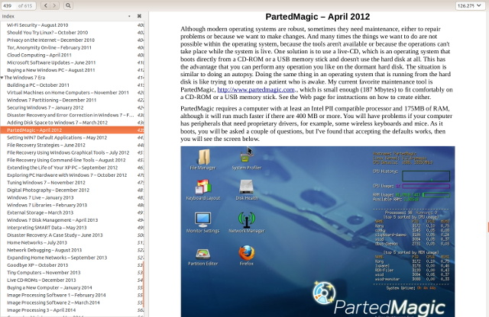

Because the page format is fixed, the reader can enlarge the print only by enlarging the window or closing the sidebar that shows the table of contents. Once the page fills the screen, further enlargement will require horizontal scrolling to read each line. Also, not all pdf readers can display the table of contents in a sidebar.

By contrast e-book files are not images of a printed pages but collections of text and images with instructions on how they should appear. They are closely related to the HTML files that your browser displays when you access a Website. The user sets the font size he or she finds comfortable, and the reader program or device adjusts the number of characters per line and the number of lines to fit the screen. The table of contents typically appears in a sidebar that the user opens only when needed. This makes it easy to skip through a book, assuming of course that the entries in the table of contents are meaningful. In my experience, e-book files are about two-thirds the size of equivalent PDF images and half that of the word-processor source files. However, because font sizes, line lengths, and the number of lines per screen is set by the reader, the author loses some control over the appearance of the document. Readers need either e-book software for their computers or hardware readers, such as Kindles. The author needs software to convert a word-processor file to an e-book one, and typically this is not from the same company that supplied your word processor, with the result that there can be errors in the conversion process. The next screen-shot shows an e-book reader displaying an e-book library.
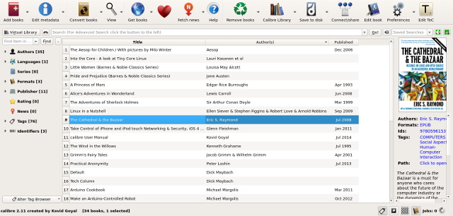

The menu bar icons are the operations you can perform on the e-books, the right sidebar shows the selected book's cover and some information about it, and the left sidebar shows statistics on the library. The next two screen-shots show a page of an e-book as displayed by the reader, first with the table of contents sidebar open and then with it closed.
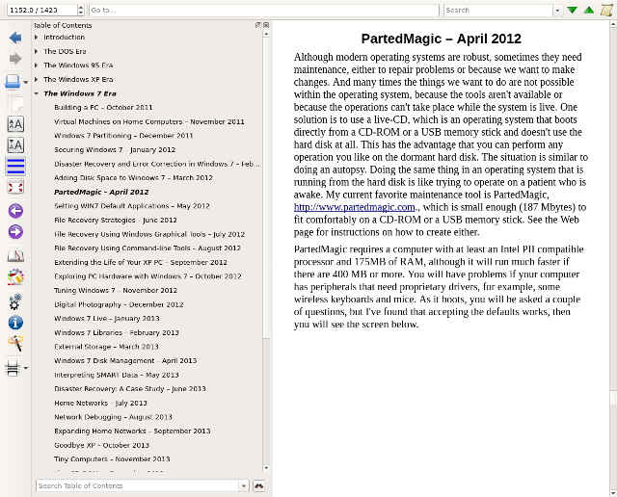

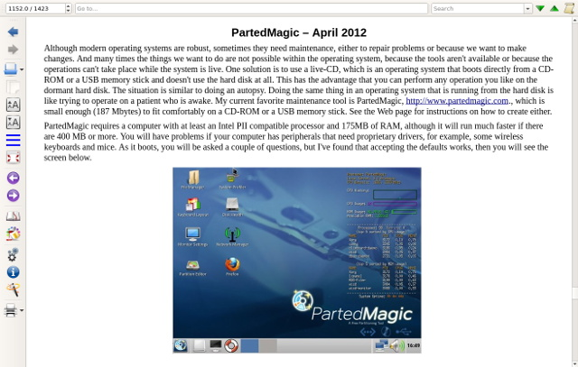

There are many programs available to create e-books; I use Calibre http://calibre-ebook.com/) because it's free and is available for Linux, OS X, and Windows. Regardless of what e-book software you prefer, the process will be similar. You first create the source material using the word processor of your choice. Here is where you'll correct the typos and establish consistent formatting. It is important to use styles for your formatting. For example, your word processor has defined several levels of headings, and you should use these as Calibre will generate a table of contents from them. A table of contents is irrelevant in a novel, but can be very important for other types of books.

The next screen-shot shows the first step of conversion.
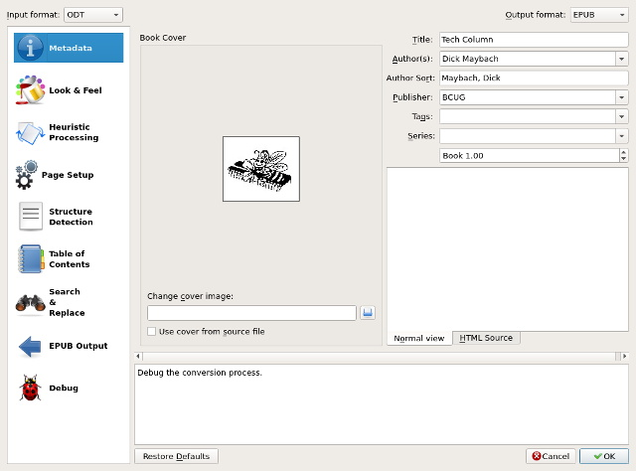

The left sidebar shows the operations you can perform. In my case, I needed only to select a cover and set-up the table of contents, as shown in the next screen-shot.
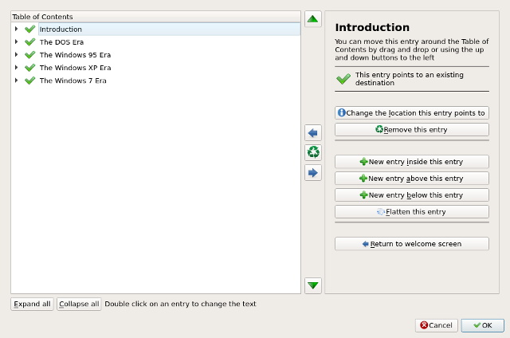

Only the major headings are shown here; each could be expanded to show the sub-levels.
The conversion process is iterative, especially so the first time you do it. You will surely find conversion artifacts that require correction using the word-processor. Expect to repeat this many, many times. If you use Calibre, your first conversion will be to an epub file. Do not generate a table of contents using your word processor, but let Calibre do it from your section headings. Calibre first converts the word-processor file to HTML, and you may get better results if you let your word processor make this preliminary conversion. You can fine tune the appearance of your e-book by editing the HTML. I didn't find this to be necessary, although I did have to make some adjustments in the table of contents. Calibre allows this fine-tuning only on epub files, which is why you create this form first. Carefully proof the result. I've found that most errors result from problems in the word-processor file. In particular, I've fixed many problems by deleting and re-entering headings. I've also found that the size (in pixels) of images is important. While a word processor will accept an image of almost any size and allow you to change its size on the page, the new size is often not preserved in the e-book file. Once you are satisfied with the epub file, you can convert it to another e-book format, but the conversion may introduce artifacts.

You will probably get the best results by using your word processor to create a pdf file, rather than going through an e-book program. I use LibreOffice, which creates a pdf file with a table of contents that appears in a sidebar in many pdf readers. However not all pdf readers have this feature. To be safe, you should have your word processor generate a table of contents, which will appear at the start of the document. This makes it less convenient than a sidebar, but far better than nothing.

To accommodate your readers, you should provide your e-book in both pdf and epub formats, which will let almost everybody read them. You could also include azw3, since Kindle readers are quite common. (If possible avoid the older Kindle format, Mobi, as it has many idiosyncrasies and often doesn't display properly.)

References
- Ali Luke - Publishing E-Books for Dummies, John Wiley & Sons, Inc., 2012
- http://www.wikihow.com/Write-Your-First-eBook

